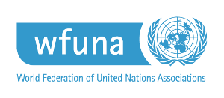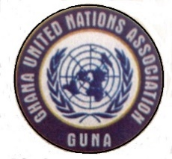

**Headquarters:**

P.O. Box AN 12308 Accra, Ghana

Tel. +233 (0) 505720008 / 0269605536

Web. [www.gunagh.org](http://www.gunagh.org)

Email: [info@gunagh.org](mailto:info@gunagh.org)

Ghana

National Headquarters

United Nations

In Partnership with:

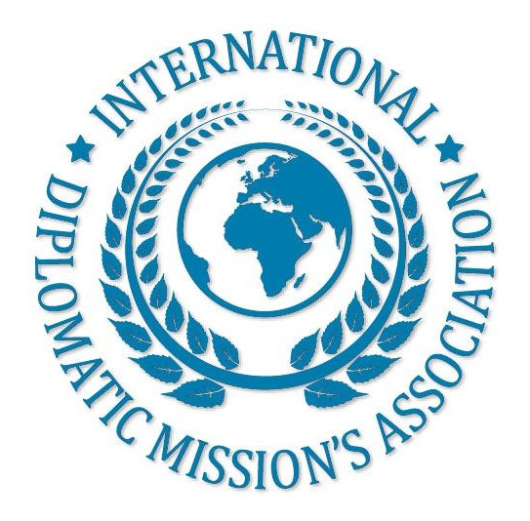

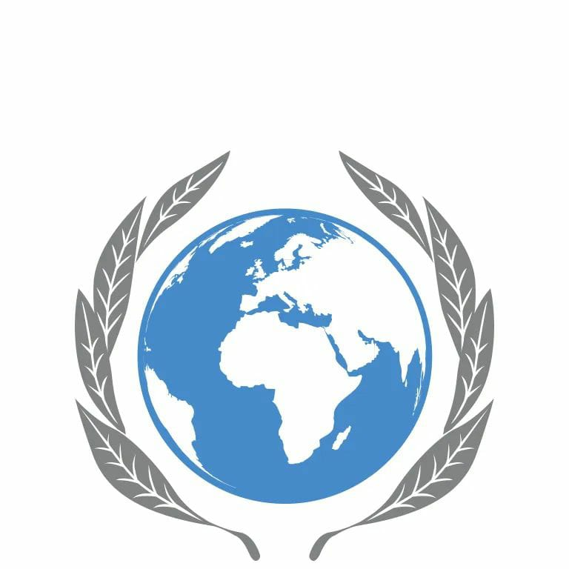

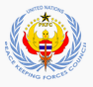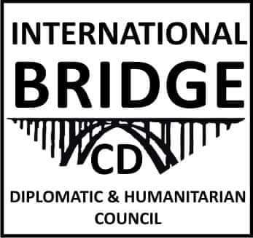









AFFILIATES

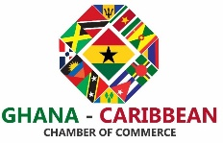

PRESS RELEASE

GHANA UNITED NATIONS ASSOCIATION (GUNA)

ON THE ENVIRONMENTAL DEGRADATION CAUSED BY GALAMSEY (ILLEGAL MINING) ACTIVITIES IN THE REPUBLIC OF GHANA

Date: [Thursday 12th September 2024]

FOR IMMEDIATE RELEASE

The Ghana United Nations Association (GUNA) expresses grave concern over the escalating environmental degradation caused by the pervasive and destructive activities of illegal mining, known locally as "galamsey," in the Republic of Ghana. This press release addresses the urgent need for concerted action to protect our environment, public health, and the future of our communities.

**The Crisis at Hand**

“Galamsey” activities have become a significant threat to Ghana's environment, economy, and public health. Despite numerous efforts by the government, civil society, and environmental advocates, illegal mining continues to ravage our lands, contaminate our water bodies, and jeopardize the livelihoods of countless Ghanaians. The consequences of these unregulated mining operations include:

Severe Land Degradation: Large tracts of fertile land are being destroyed by illegal mining operations, leaving behind barren and hazardous landscapes. These activities strip the soil of its nutrients, making it impossible for agriculture to thrive, thus undermining food security.

Water Pollution: “Galamsey” has led to the contamination of major rivers and water bodies with harmful chemicals, including mercury and cyanide. This pollution poses serious health risks to communities that rely on these waters for drinking, fishing, and irrigation, and it disrupts aquatic ecosystems.

Deforestation: Illegal mining is a significant driver of deforestation, contributing to the loss of biodiversity and the destruction of vital forest cover that helps regulate the climate and provides habitat for wildlife.

Public Health Hazards: The use of toxic chemicals in “galamsey” operations endangers not only the miners but also the communities living near these sites. Exposure to mercury and other hazardous substances can lead to severe health issues, including neurological damage and birth defects.

Economic Impact: While illegal mining provides short-term financial gains to a few, the long-term economic impact is detrimental to the nation. The destruction of arable land and pollution of water sources threaten agriculture, a critical sector of the Ghanaian economy, and undermine sustainable development efforts.

**Call to Action**

The Ghana United Nations Association calls on all stakeholders, including the government, traditional leaders, local communities, civil society, and the private sector, to take urgent and coordinated action to address this crisis. We urge the following measures:

Strengthen Law Enforcement: The government must intensify efforts to enforce existing environmental laws and regulations, prosecute offenders, and dismantle the networks that enable illegal mining operations.

Promote Sustainable Mining Practices: We advocate for the promotion of legal and sustainable mining practices that protect the environment while contributing to the economy. This includes supporting small-scale miners in obtaining licenses and adhering to environmentally friendly practices.

Community Engagement and Education: There is a need for increased education and awareness campaigns to inform communities about the dangers of “galamsey” and the benefits of protecting the environment. Engaging local communities as active participants in the fight against illegal mining is crucial for long-term success.

Restore Degraded Lands: A national effort to rehabilitate and restore lands devastated by illegal mining is essential. This includes reforestation projects, soil restoration, and the cleaning of polluted water bodies to revive ecosystems and support sustainable livelihoods.

International Support and Partnerships: GUNA calls on international partners, including the United Nations, to support Ghana in its efforts to combat illegal mining through technical assistance, funding for environmental restoration, and capacity-building initiatives.

**Conclusion**

The environmental degradation caused by “galamsey” is not just a national issue; it is a crisis that threatens our collective future. GUNA remains committed to supporting all efforts aimed at eradicating illegal mining and promoting sustainable development in Ghana. We believe that through collaborative and decisive action, we can protect our environment and ensure a healthier and more prosperous future for all Ghanaians.

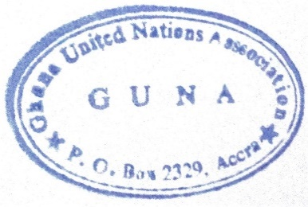For media inquiries, please contact:

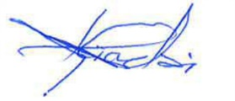

[SELAASIE LHAL HIADZI]

[DIRECTOR OF ADMINISTRATION]

Ghana United Nations Association (GUNA)

[054-363-7443]

[selaasie1@yahoo.co.uk]