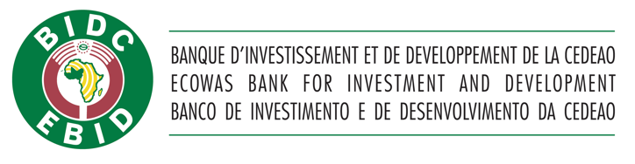

**THE ECOWAS BANK FOR INVESTMENT AND DEVELOPMENT WINS THE AFRICA SUSTAINABILITY AWARD**

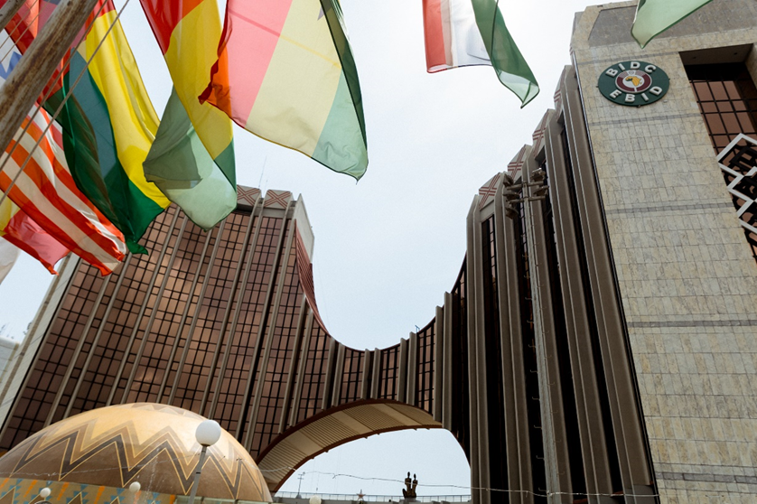

|  |
| --- |
|  |
|  |

In a landmark achievement, the Advisory Board of the African Sustainability Awards in partnership with United Nations Educational, Scientific and Cultural Organization (UNESCO) has selected the ECOWAS Bank for Investment and Development (EBID) as the winner of the *Financial Institution of the Year – Africa* category at the Africa Sustainability Awards. The award will be presented during an event slated for 30th December 2024 at the Accra International Conference, Accra, Ghana.

This award recognizes EBID's outstanding dedication to sustainable practices across Africa and its commitment in advancing Africa’s environmental, social and economic progress in line with the UN Sustainable Development Goals (SDGs).

In line with its mission of improving access to sustainable financial resources in West Africa, the Bank has to-date committed over USD1 billion to sustainability-driven projects, guided by its Strategy for 2021-25.

The Bank’s attention to sustainable initiatives has gained international recognition such that the European Investment Bank (EIB) recently extended a line of credit in the amount of EUR 100 million to support climate-friendly and sustainable projects in the ECOWAS sub-region.

It will be recalled that in February 2023, EBID published its first Environmental, Social and Governance (ESG) Finance Framework, formalizing its commitment to green financing and sustainability initiatives. This was followed by the maiden edition of the Bank’s informative series dubbed “The *President's Round Table”* on the theme "Greening West Africa" in October 2023. The program, which gathered environmental and sustainability experts from across the continent, focused on the effects of climate change in West Africa and made proposals for climate-conscious economic development.

Additionally, EBID recently made history as the first Development Finance Institution (DFI) to issue a Green, Social and Sustainable (GSS) Bond on the UEMOA regional financial market, the *Bourse Régionale des Valeurs Mobilières* (BRVM) which was oversubscribed within a space of 48 hours. The Bank is also in the process of finalizing its accreditation to the Green Climate Fund (GCF) and in that regard, recently received a high-level delegation from GCF, South Korea, for discussions on measures aimed at positioning the Bank to better support the sub-region in this area.

The African Sustainability Awards (ASA) is a platform that honours individuals, organisations, businesses, NGOs and government bodies that demonstrate a high commitment to sustainable practices.

**\*\*\***

**About EBID**

**ECOWAS Bank for Investment and Development (EBID)** is the development finance institution of the Economic Community of West African States (ECOWAS) comprising fifteen (15) Member States namely, Benin, Burkina Faso, Cape Verde, Côte d’Ivoire, The Gambia, Ghana, Guinea, Guinea-Bissau, Liberia, Mali, Niger, Nigeria, Senegal, Sierra Leone and Togo. Based in Lomé, Togolese Republic, the Bank is committed to financing developmental projects and programmes covering diverse initiatives from infrastructure and basic amenities, rural development and environment, industry, and social services sectors, through its private and public sector windows. EBID intervenes through long, medium, and short-term loans, equity participation, lines of credit, refinancing, financial engineering operations, and related services.

[www.bidc-ebid.org](http://www.bidc-ebid.org)

**Press** **Contact**

COMMUNICATION AND

EXTERNAL RELATIONS UNIT

[asomda@bidc-ebid.org](mailto:asomda@bidc-ebid.org)

+228 22 21 68 64